Mineral Titles Act
NOTICE OF GRANT OF A MINERAL TITLE
Title Type and Number: | Exploration Licence 32478
Granted: | 08 October 2021, for a period of 6 Years
Area: | 250 Blocks, 798.52 km²
Locality: | FLYNN
Name of Holder/s: | 100% BAUDIN RESOURCES PTY LTD [ACN. 618 455 593]
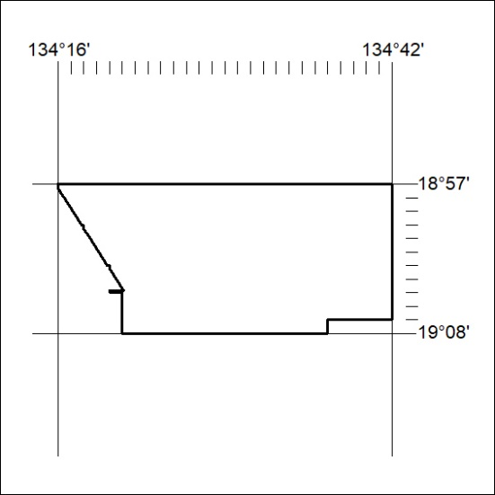
Area granted is indicated above. The titleholder is not permitted to exercise occupational rights on any land that is subject to a development title, or an application for a development title. Any land the subject of a Reserved Land gazettal under the Mineral Titles Act and all land vested in the Commonwealth of Australia is also excluded by description but not excised from the grant area.
375/21

Mineral Titles Act
NOTICE OF GRANT OF A MINERAL TITLE
Title Type and Number: | Exploration Licence 32640
Granted: | 08 October 2021, for a period of 6 Years
Area: | 188 Blocks, 618.83 km²
Locality: | PIGEON
Name of Holder/s: | 100% ALBIAN RESOURCES PTY LTD [ACN. 629 786 161]
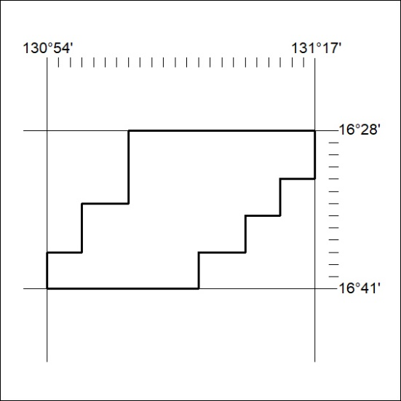
Area granted is indicated above. The titleholder is not permitted to exercise occupational rights on any land that is subject to a development title, or an application for a development title. Any land the subject of a Reserved Land gazettal under the Mineral Titles Act and all land vested in the Commonwealth of Australia is also excluded by description but not excised from the grant area.
376/21

Mineral Titles Act
NOTICE OF GRANT OF A MINERAL TITLE
Title Type and Number: | Exploration Licence 32641
Granted: | 08 October 2021, for a period of 6 Years
Area: | 115 Blocks, 340.91 km²
Locality: | MT SANFORD
Name of Holder/s: | 100% ALBIAN RESOURCES PTY LTD [ACN. 629 786 161]
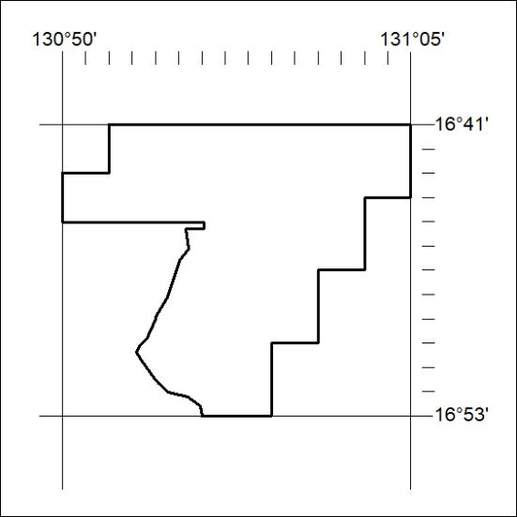
Area granted is indicated above. The titleholder is not permitted to exercise occupational rights on any land that is subject to a development title, or an application for a development title. Any land the subject of a Reserved Land gazettal under the Mineral Titles Act and all land vested in the Commonwealth of Australia is also excluded by description but not excised from the grant area.
377/21

