Mineral Titles Act 2010
NOTICE OF LAND CEASING TO BE A MINERAL TITLE AREA
Title Type and Number: | Exploration Licence 32289
Area Ceased on: | 15 September 2021
Area: | 26 Blocks, 84.06 km²
Locality: | DALMORE
Name of Applicant(s)/Holder(s): | 90% INCA MINERALS LIMITED [ACN. 128 512 907], 5% MRG RESOURCES PTY LTD [ACN. 614 946 164], 5% WEST Jonathan
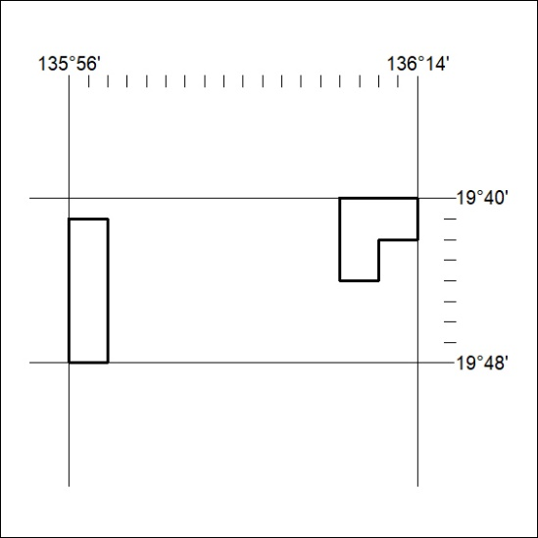
(Area now amalgamated into Exploration Licence 32795 under s102 – EL moratorium period does not apply)
354/21

Mineral Titles Act 2010
NOTICE OF LAND CEASING TO BE A MINERAL TITLE AREA
Title Type and Number: | Exploration Licence 32635
Area Ceased on: | 15 September 2021
Area: | 2 Blocks, 6.47 km²
Locality: | DALMORE
Name of Applicant(s)/Holder(s): | 90% INCA MINERALS LIMITED [ACN. 128 512 907], 5% MRG RESOURCES PTY LTD [ACN. 614 946 164], 5% WEST Jonathan
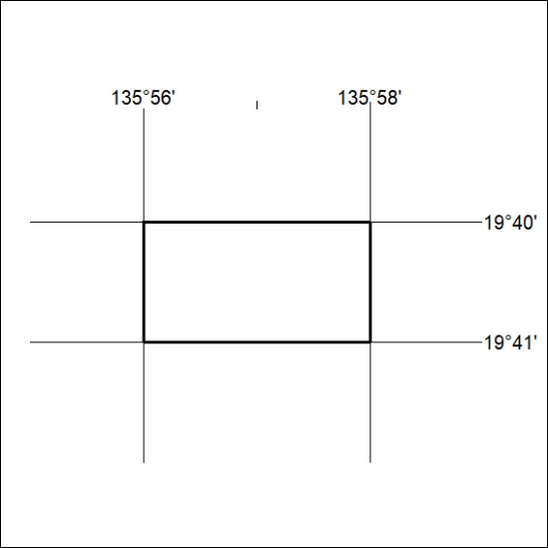
(Area now amalgamated into Exploration Licence 32795 under s102 – EL moratorium period does not apply)
355/21

