Mineral Titles Act 2010
NOTICE OF LAND CEASING TO BE A MINERAL TITLE AREA
Title Type and Number: | Exploration Licence 27137
Area Ceased on: | 02 September 2021
Area: | 4 Blocks, 13.35 km²
Locality: | RANFORD HILL
Name of Applicant(s)/Holder(s): | 100% WRIGHT Anthony
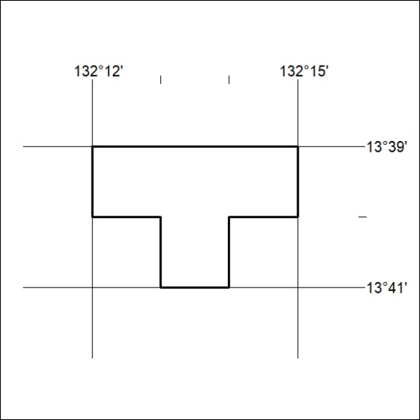

342/21

Mineral Titles Act
NOTICE OF GRANT OF A MINERAL TITLE
Title Type and Number: | Exploration Licence 32513
Granted: | 02 September 2021, for a period of 6 Years
Area: | 20 Blocks, 63.19 km²
Locality: | QUARTZ
Name of Holder/s: | 100% BARFUSS CORPORATION PTY. LTD. [ACN. 006 917 666]
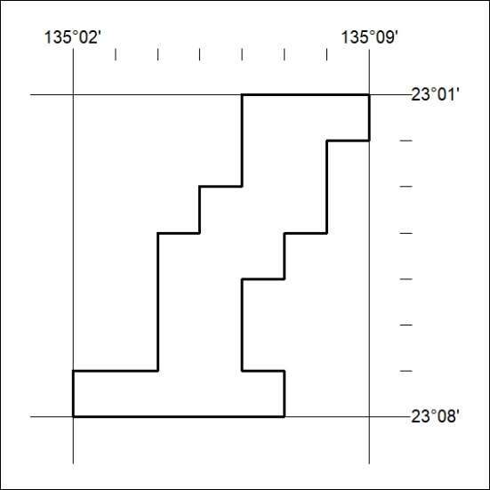
Area granted is indicated above. The titleholder is not permitted to exercise occupational rights on any land that is subject to a development title, or an application for a development title. Any land the subject of a Reserved Land gazettal under the Mineral Titles Act and all land vested in the Commonwealth of Australia is also excluded by description but not excised from the grant area.

343/21

