Mineral Titles Act 2010
NOTICE OF LAND CEASING TO BE A MINERAL TITLE AREA
Title Type and Number: | Exploration Licence 32362
Area Ceased on: | 13 July 2021
Area: | 16 Blocks, 51.89 km²
Locality: | ALROY
Name of Applicant(s)/Holder(s): | 100% MINEX CRC LTD [ACN. 625 533 913]
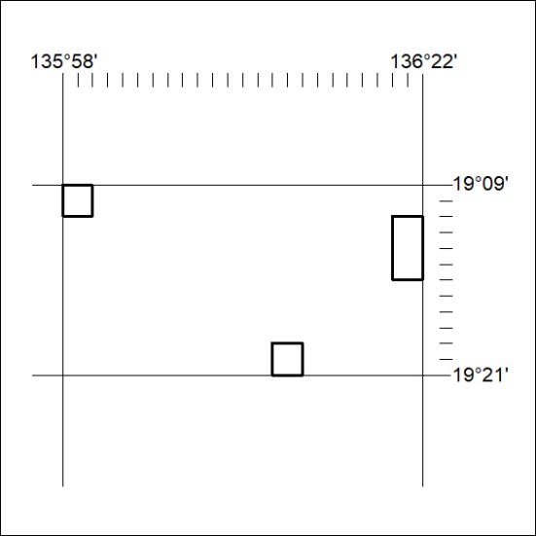

262/21

Mineral Titles Act 2010
NOTICE OF LAND CEASING TO BE A MINERAL TITLE AREA
Title Type and Number: | Exploration Licence 32363
Area Ceased on: | 13 July 2021
Area: | 16 Blocks, 51.79 km²
Locality: | WONARAH
Name of Applicant(s)/Holder(s): | 100% MINEX CRC LTD [ACN. 625 533 913]
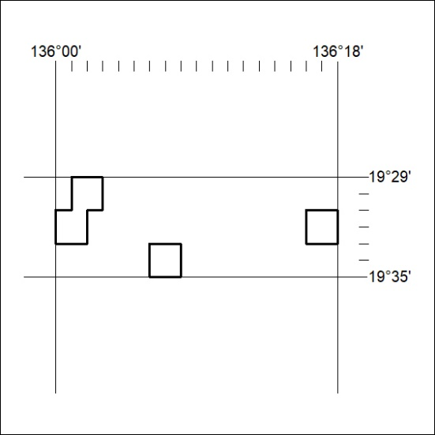

263/21
Mineral Titles Act 2010
NOTICE OF LAND CEASING TO BE A MINERAL TITLE AREA
Title Type and Number: | Exploration Licence 32364
Area Ceased on: | 13 July 2021
Area: | 12 Blocks, 38.82 km²
Locality: | DALMORE
Name of Applicant(s)/Holder(s): | 100% MINEX CRC LTD [ACN. 625 533 913]
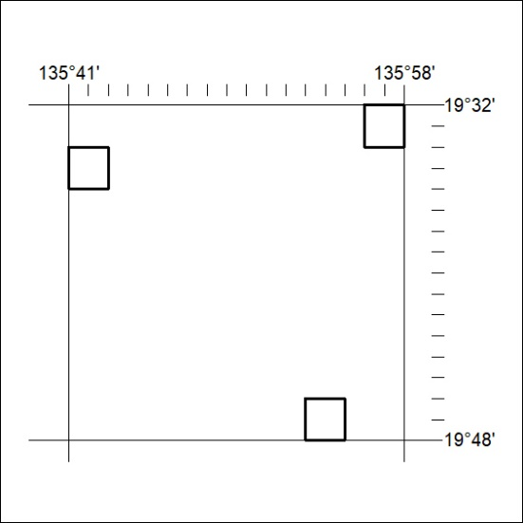

264/21

Mineral Titles Act 2010
NOTICE OF LAND CEASING TO BE A MINERAL TITLE AREA
Title Type and Number: | Exploration Licence 32365
Area Ceased on: | 13 July 2021
Area: | 5 Blocks, 10.73 km²
Locality: | DALMORE
Name of Applicant(s)/Holder(s): | 100% MINEX CRC LTD [ACN. 625 533 913]
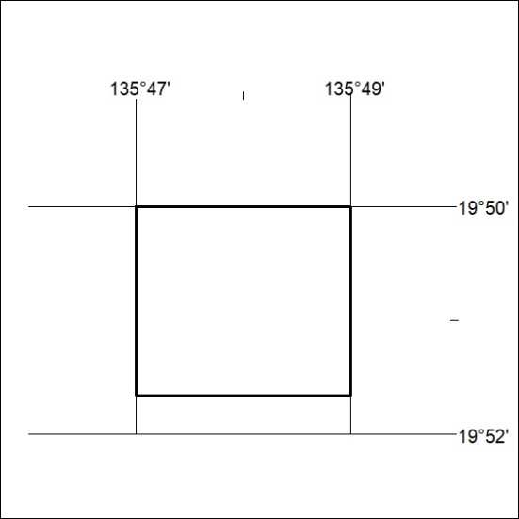

265/21
Mineral Titles Act 2010
NOTICE OF LAND CEASING TO BE A MINERAL TITLE AREA
Title Type and Number: | Exploration Licence 32366
Area Ceased on: | 13 July 2021
Area: | 7 Blocks, 22.72 km²
Locality: | GALLIPOLI
Name of Applicant(s)/Holder(s): | 100% MINEX CRC LTD [ACN. 625 533 913]
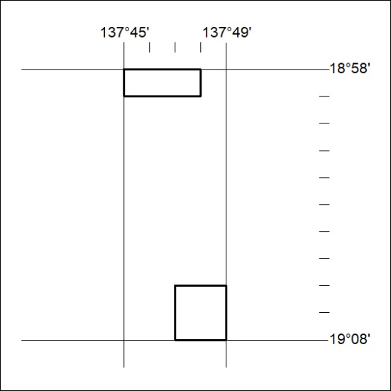

266/21

Mineral Titles Act
NOTICE OF GRANT OF A MINERAL TITLE
Title Type and Number: | Exploration Licence 32336
Granted: | 06 July 2021, for a period of 6 Years
Area: | 4 Blocks, 12.78 km²
Locality: | AMMAROO
Name of Holder/s: | 50% SMITH Scott William, 50% SMITH Kimberley Alice
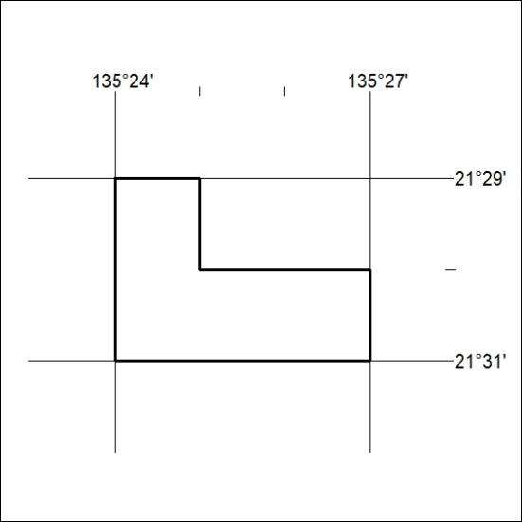
Area granted is indicated above. The titleholder is not permitted to exercise occupational rights on any land that is subject to a development title, or an application for a development title. Any land the subject of a Reserved Land gazettal under the Mineral Titles Act and all land vested in the Commonwealth of Australia is also excluded by description but not excised from the grant area.

267/21

Mineral Titles Act
NOTICE OF GRANT OF A MINERAL TITLE
Title Type and Number: | Exploration Licence 32617
Granted: | 12 July 2021, for a period of 6 Years
Area: | 90 Blocks, 284.34 km²
Locality: | FREWENA
Name of Holder/s: | 100% STRATEGIC ENERGY RESOURCES LIMITED* [ACN. 051 212 429]
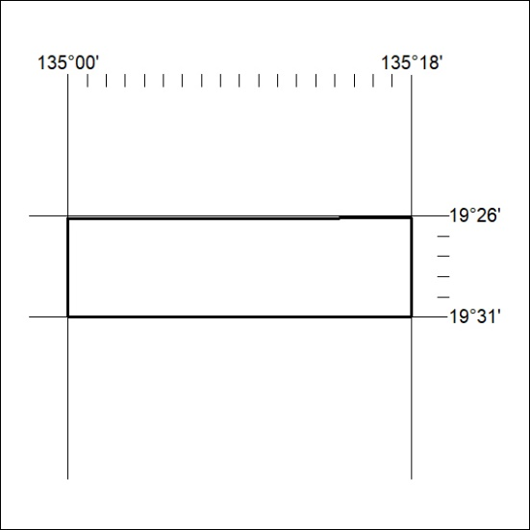
Area granted is indicated above. The titleholder is not permitted to exercise occupational rights on any land that is subject to a development title, or an application for a development title. Any land the subject of a Reserved Land gazettal under the Mineral Titles Act and all land vested in the Commonwealth of Australia is also excluded by description but not excised from the grant area.

268/21

