Mineral Titles Act 2010
NOTICE OF LAND CEASING TO BE A MINERAL TITLE AREA
Title Type and Number: | Exploration Licence 31950
Area Ceased on: | 07 May 2021
Area: | 143 Blocks, 397.44 km²
Locality: | MACDONNELL RANGES
Name of Applicant(s)/Holder(s): | 100% MAGNET EXPLORATION PTY LTD [ACN. 623 568 918]
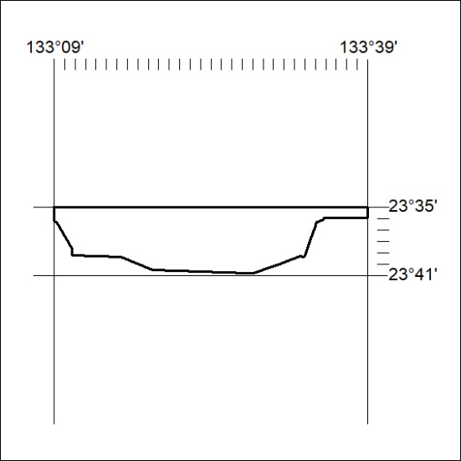

131/21

Mineral Titles Act 2010
NOTICE OF LAND CEASING TO BE A MINERAL TITLE AREA
Title Type and Number: | Exploration Licence 31997
Area Ceased on: | 07 May 2021
Area: | 27 Blocks, 87.59 km²
Locality: | FLYNN
Name of Applicant(s)/Holder(s): | 100% MAGNET EXPLORATION PTY LTD [ACN. 623 568 918]
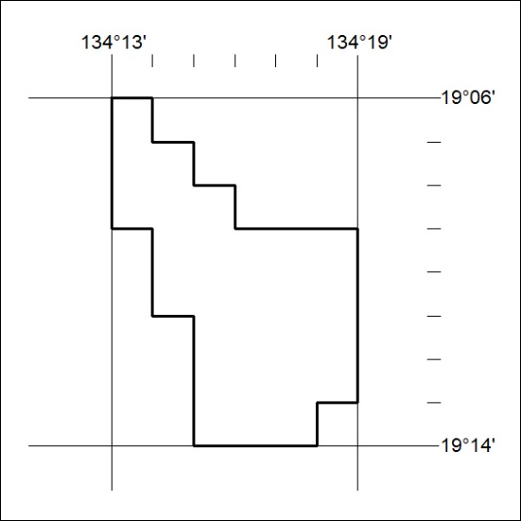

132/21
Mineral Titles Act 2010
NOTICE OF LAND CEASING TO BE A MINERAL TITLE AREA
Title Type and Number: | Exploration Licence 31998
Area Ceased on: | 07 May 2021
Area: | 69 Blocks, 220.69 km²
Locality: | ELKEDRA
Name of Applicant(s)/Holder(s): | 100% MAGNET EXPLORATION PTY LTD [ACN. 623 568 918]
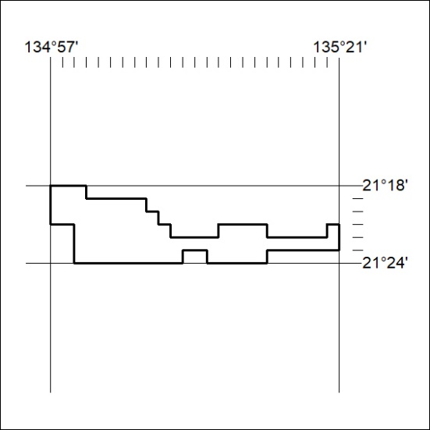

133/21

Mineral Titles Act 2010
NOTICE OF LAND CEASING TO BE A MINERAL TITLE AREA
Title Type and Number: | Exploration Licence 31999
Area Ceased on: | 07 May 2021
Area: | 221 Blocks, 730.06 km²
Locality: | DELAMERE
Name of Applicant(s)/Holder(s): | 100% MAGNET EXPLORATION PTY LTD [ACN. 623 568 918]
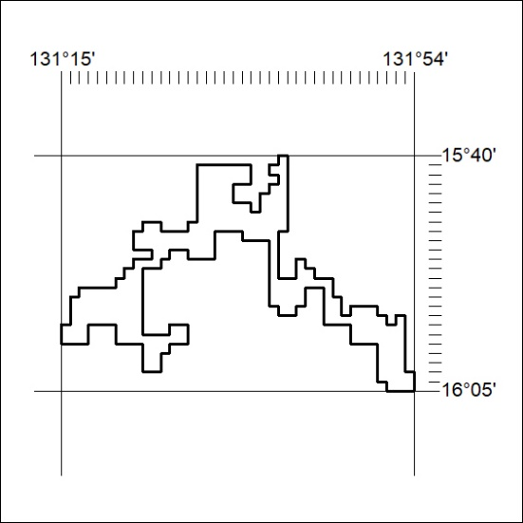

134/21
Mineral Titles Act 2010
NOTICE OF LAND CEASING TO BE A MINERAL TITLE AREA
Title Type and Number: | Exploration Licence 32000
Area Ceased on: | 07 May 2021
Area: | 232 Blocks, 762.68 km²
Locality: | MONTEJINNI
Name of Applicant(s)/Holder(s): | 100% MAGNET EXPLORATION PTY LTD [ACN. 623 568 918]
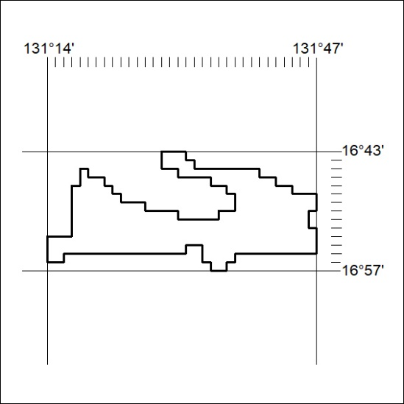

135/21

Mineral Titles Act 2010
NOTICE OF LAND CEASING TO BE A MINERAL TITLE AREA
Title Type and Number: | Exploration Licence 32019
Area Ceased on: | 07 May 2021
Area: | 184 Blocks, 584.45 km²
Locality: | SANDOVER
Name of Applicant(s)/Holder(s): | 100% MAGNET EXPLORATION PTY LTD [ACN. 623 568 918]
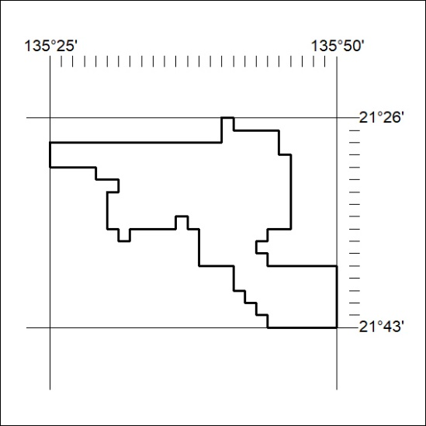

136/21

Mineral Titles Act
NOTICE OF GRANT OF A MINERAL TITLE
Title Type and Number: | Exploration Licence 32417
Granted: | 07 May 2021, for a period of 6 Years
Area: | 16 Blocks, 53.37 km²
Locality: | PINE CREEK
Name of Holder/s: | 33.34% TEELOW Leslie John, 33.33% FRANCIS Jason Ross, 33.33% TEELOW Michael Daniel
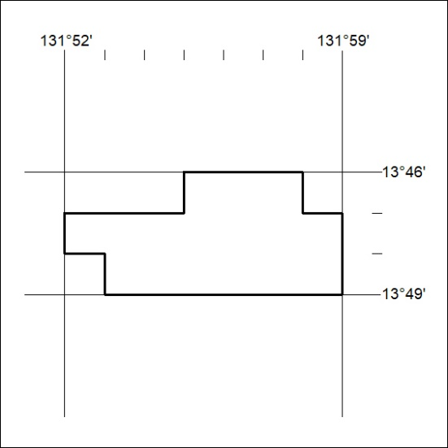
Area granted is indicated above. The titleholder is not permitted to exercise occupational rights on any land that is subject to a development title, or an application for a development title. Any land the subject of a Reserved Land gazettal under the Mineral Titles Act and all land vested in the Commonwealth of Australia is also excluded by description but not excised from the grant area.
137/21

Mineral Titles Act
NOTICE OF GRANT OF A MINERAL TITLE
Title Type and Number: | Exploration Licence 32498
Granted: | 07 May 2021, for a period of 6 Years
Area: | 22 Blocks, 73.58 km²
Locality: | BATCHELOR
Name of Holder/s: | 100% WESTERN FRONTIER PTY LTD [ACN. 622 913 071]
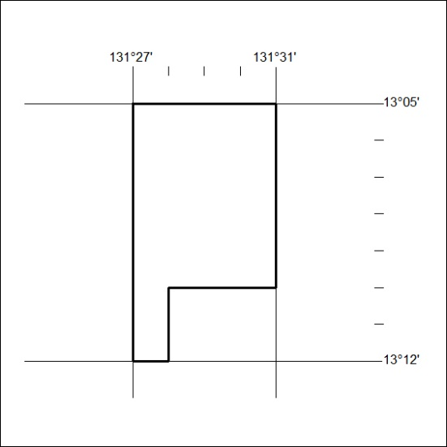
Area granted is indicated above. The titleholder is not permitted to exercise occupational rights on any land that is subject to a development title, or an application for a development title. Any land the subject of a Reserved Land gazettal under the Mineral Titles Act and all land vested in the Commonwealth of Australia is also excluded by description but not excised from the grant area.
138/21

Mineral Titles Act
NOTICE OF GRANT OF A MINERAL TITLE
Title Type and Number: | Extractive Mineral Lease 32262
Granted: | 07 May 2021, for a period of 10 Years
Area: | 6.20 Hectares
Locality: | MARY RIVER
Name of Holder/s: | 100% AUSTMIN DEVELOPMENT PTY LTD [ACN. 108 019 585]
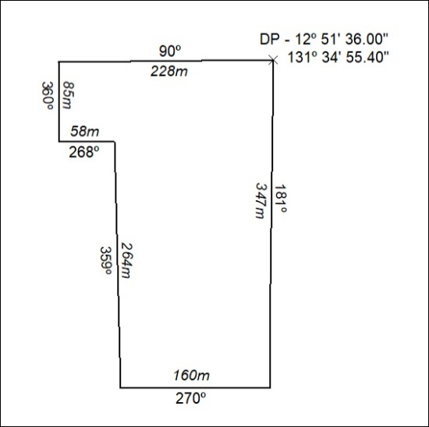

139/21

Mineral Titles Act
NOTICE OF GRANT OF A MINERAL TITLE
Title Type and Number: | Extractive Mineral Exploration Licence 32585
Granted: | 07 May 2021, for a period of 2 Years
Area: | 4 Blocks, 13.21 km²
Locality: | LARRIMAH
Name of Holder/s: | 100% TERRITORY SANDS PTY LTD [ACN. 632 797 972]
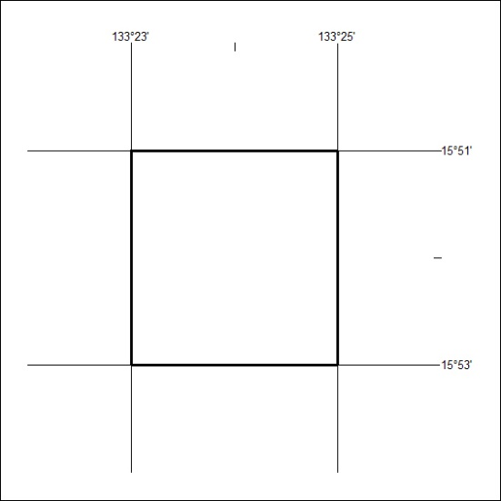
Area granted is indicated above. The titleholder is not permitted to exercise occupational rights on any land that is subject to a development title, or an application for a development title. Any land the subject of a Reserved Land gazettal under the Mineral Titles Act and all land vested in the Commonwealth of Australia is also excluded by description but not excised from the grant area.
140/21

Mineral Titles Act
NOTICE OF GRANT OF A MINERAL TITLE
Title Type and Number: | Extractive Mineral Exploration Licence 32586
Granted: | 07 May 2021, for a period of 2 Years
Area: | 4 Blocks, 13.23 km²
Locality: | WESTERN CREEK
Name of Holder/s: | 100% TERRITORY SANDS PTY LTD [ACN. 632 797 972]
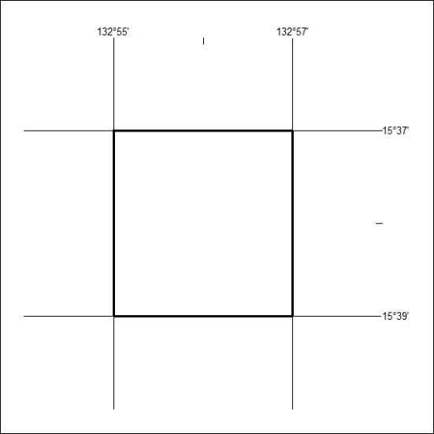
Area granted is indicated above. The titleholder is not permitted to exercise occupational rights on any land that is subject to a development title, or an application for a development title. Any land the subject of a Reserved Land gazettal under the Mineral Titles Act and all land vested in the Commonwealth of Australia is also excluded by description but not excised from the grant area.
141/21

Mineral Titles Act
NOTICE OF GRANT OF A MINERAL TITLE
Title Type and Number: | Extractive Mineral Exploration Licence 32587
Granted: | 07 May 2021, for a period of 2 Years
Area: | 4 Blocks, 13.23 km²
Locality: | WESTERN CREEK
Name of Holder/s: | 100% TERRITORY SANDS PTY LTD [ACN. 632 797 972]
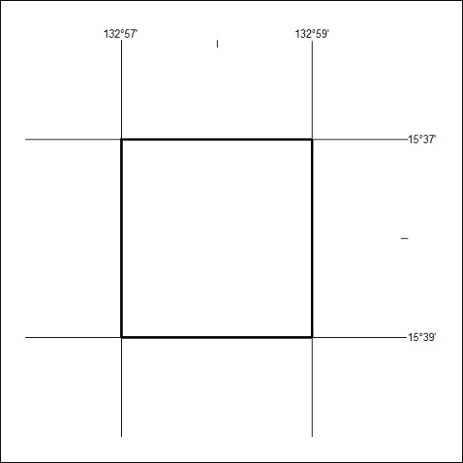
Area granted is indicated above. The titleholder is not permitted to exercise occupational rights on any land that is subject to a development title, or an application for a development title. Any land the subject of a Reserved Land gazettal under the Mineral Titles Act and all land vested in the Commonwealth of Australia is also excluded by description but not excised from the grant area.
142/21

Mineral Titles Act
NOTICE OF GRANT OF A MINERAL TITLE
Title Type and Number: | Extractive Mineral Exploration Licence 32589
Granted: | 07 May 2021, for a period of 2 Years
Area: | 4 Blocks, 13.13 km²
Locality: | NEWCASTLE WATERS
Name of Holder/s: | 100% TERRITORY SANDS PTY LTD [ACN. 632 797 972]
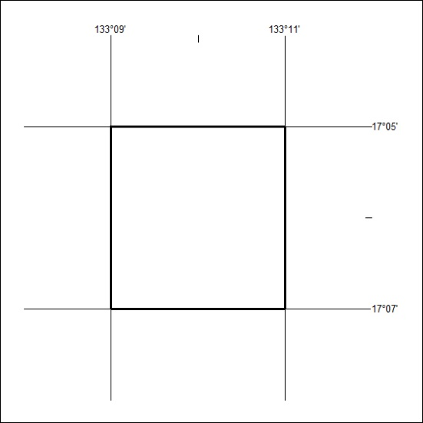
Area granted is indicated above. The titleholder is not permitted to exercise occupational rights on any land that is subject to a development title, or an application for a development title. Any land the subject of a Reserved Land gazettal under the Mineral Titles Act and all land vested in the Commonwealth of Australia is also excluded by description but not excised from the grant area.
143/21

Mineral Titles Act
NOTICE OF GRANT OF A MINERAL TITLE
Title Type and Number: | Extractive Mineral Exploration Licence 32593
Granted: | 07 May 2021, for a period of 2 Years
Area: | 4 Blocks, 13.23 km²
Locality: | LARRIMAH
Name of Holder/s: | 100% TERRITORY SANDS PTY LTD [ACN. 632 797 972]
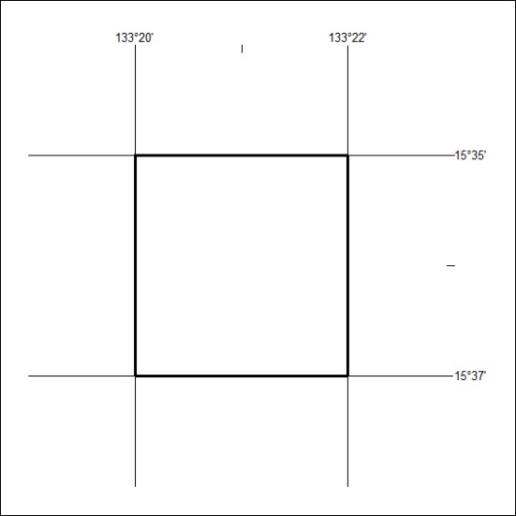
Area granted is indicated above. The titleholder is not permitted to exercise occupational rights on any land that is subject to a development title, or an application for a development title. Any land the subject of a Reserved Land gazettal under the Mineral Titles Act and all land vested in the Commonwealth of Australia is also excluded by description but not excised from the grant area.
144/21

Mineral Titles Act
NOTICE OF GRANT OF A MINERAL TITLE
Title Type and Number: | Extractive Mineral Exploration Licence 32594
Granted: | 07 May 2021, for a period of 2 Years
Area: | 4 Blocks, 13.23 km²
Locality: | LARRIMAH
Name of Holder/s: | 100% TERRITORY SANDS PTY LTD [ACN. 632 797 972]
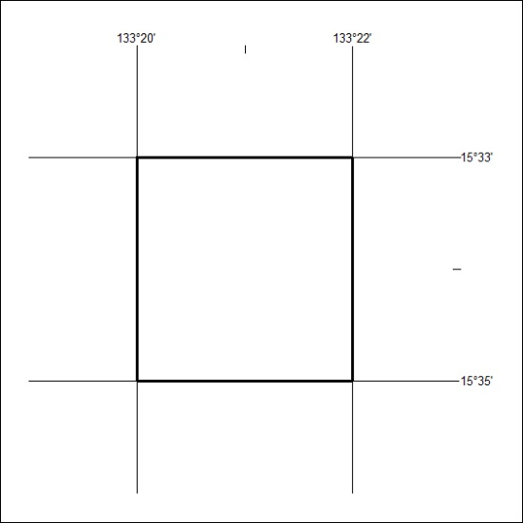
Area granted is indicated above. The titleholder is not permitted to exercise occupational rights on any land that is subject to a development title, or an application for a development title. Any land the subject of a Reserved Land gazettal under the Mineral Titles Act and all land vested in the Commonwealth of Australia is also excluded by description but not excised from the grant area.
145/21

Mineral Titles Act
NOTICE OF GRANT OF A MINERAL TITLE
Title Type and Number: | Extractive Mineral Exploration Licence 32598
Granted: | 07 May 2021, for a period of 2 Years
Area: | 4 Blocks, 13.13 km²
Locality: | MURRANJI
Name of Holder/s: | 100% TERRITORY SANDS PTY LTD [ACN. 632 797 972]
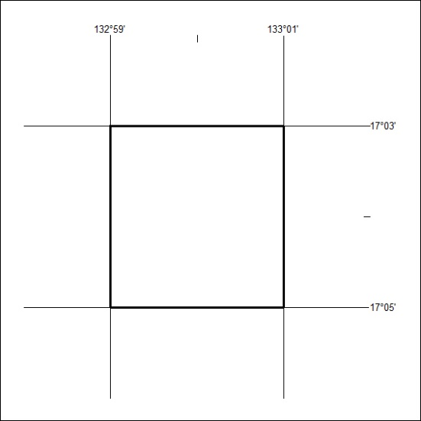
Area granted is indicated above. The titleholder is not permitted to exercise occupational rights on any land that is subject to a development title, or an application for a development title. Any land the subject of a Reserved Land gazettal under the Mineral Titles Act and all land vested in the Commonwealth of Australia is also excluded by description but not excised from the grant area.
146/21

Mineral Titles Act
NOTICE OF GRANT OF A MINERAL TITLE
Title Type and Number: | Extractive Mineral Exploration Licence 32599
Granted: | 07 May 2021, for a period of 2 Years
Area: | 4 Blocks, 13.13 km²
Locality: | NEWCASTLE WATERS
Name of Holder/s: | 100% TERRITORY SANDS PTY LTD [ACN. 632 797 972]
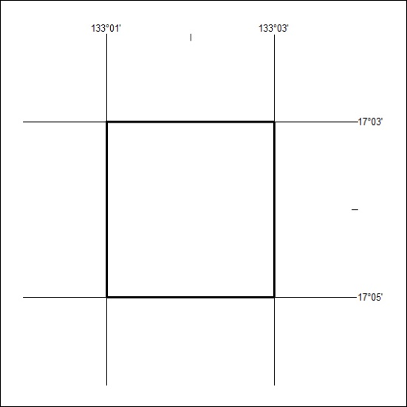
Area granted is indicated above. The titleholder is not permitted to exercise occupational rights on any land that is subject to a development title, or an application for a development title. Any land the subject of a Reserved Land gazettal under the Mineral Titles Act and all land vested in the Commonwealth of Australia is also excluded by description but not excised from the grant area.
147/21

Mineral Titles Act
NOTICE OF GRANT OF A MINERAL TITLE
Title Type and Number: | Extractive Mineral Exploration Licence 32601
Granted: | 07 May 2021, for a period of 2 Years
Area: | 4 Blocks, 13.13 km²
Locality: | MURRANJI
Name of Holder/s: | 100% TERRITORY SANDS PTY LTD [ACN. 632 797 972]
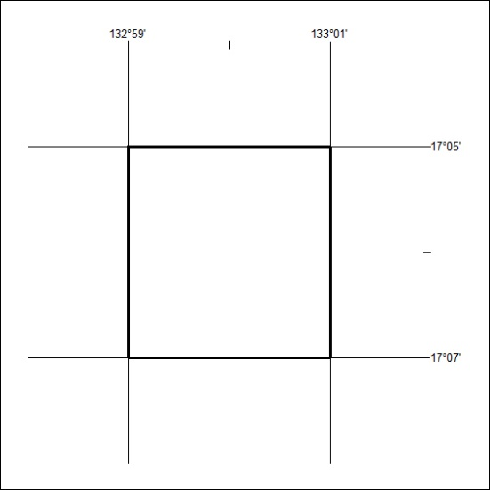
Area granted is indicated above. The titleholder is not permitted to exercise occupational rights on any land that is subject to a development title, or an application for a development title. Any land the subject of a Reserved Land gazettal under the Mineral Titles Act and all land vested in the Commonwealth of Australia is also excluded by description but not excised from the grant area.
148/21

Mineral Titles Act
NOTICE OF GRANT OF A MINERAL TITLE
Title Type and Number: | Extractive Mineral Exploration Licence 32602
Granted: | 07 May 2021, for a period of 2 Years
Area: | 4 Blocks, 13.13 km²
Locality: | NEWCASTLE WATERS
Name of Holder/s: | 100% TERRITORY SANDS PTY LTD [ACN. 632 797 972]
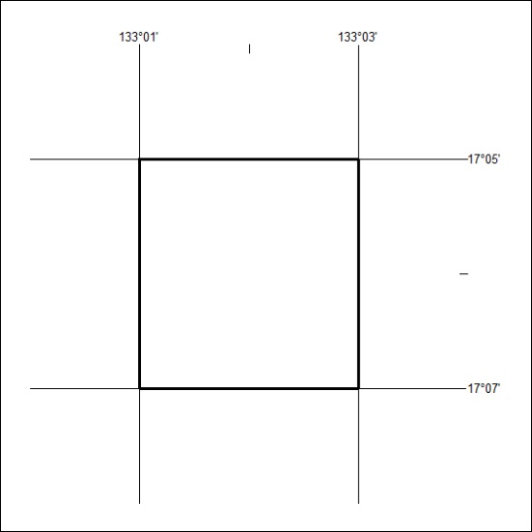
Area granted is indicated above. The titleholder is not permitted to exercise occupational rights on any land that is subject to a development title, or an application for a development title. Any land the subject of a Reserved Land gazettal under the Mineral Titles Act and all land vested in the Commonwealth of Australia is also excluded by description but not excised from the grant area.
149/21

Mineral Titles Act
NOTICE OF GRANT OF A MINERAL TITLE
Title Type and Number: | Extractive Mineral Exploration Licence 32605
Granted: | 07 May 2021, for a period of 2 Years
Area: | 4 Blocks, 13.13 km²
Locality: | NEWCASTLE WATERS
Name of Holder/s: | 100% TERRITORY SANDS PTY LTD [ACN. 632 797 972]
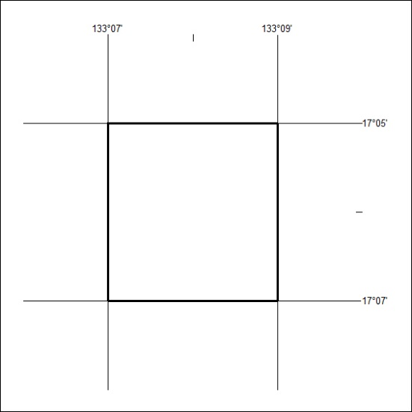
Area granted is indicated above. The titleholder is not permitted to exercise occupational rights on any land that is subject to a development title, or an application for a development title. Any land the subject of a Reserved Land gazettal under the Mineral Titles Act and all land vested in the Commonwealth of Australia is also excluded by description but not excised from the grant area.
150/21

Mineral Titles Act
NOTICE OF GRANT OF A MINERAL TITLE
Title Type and Number: | Extractive Mineral Exploration Licence 32606
Granted: | 07 May 2021, for a period of 2 Years
Area: | 4 Blocks, 13.12 km²
Locality: | NEWCASTLE WATERS
Name of Holder/s: | 100% TERRITORY SANDS PTY LTD [ACN. 632 797 972]
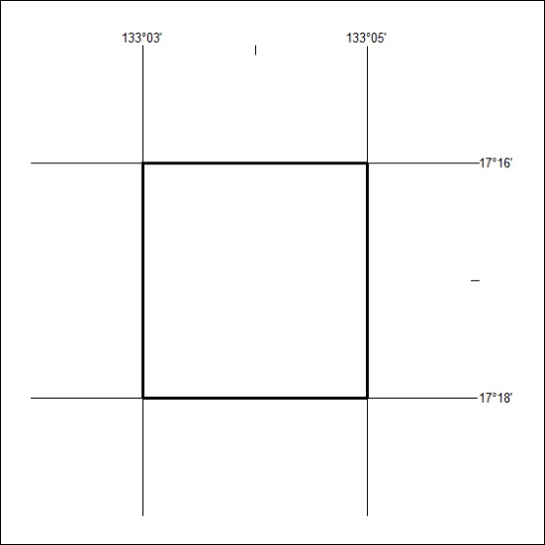
Area granted is indicated above. The titleholder is not permitted to exercise occupational rights on any land that is subject to a development title, or an application for a development title. Any land the subject of a Reserved Land gazettal under the Mineral Titles Act and all land vested in the Commonwealth of Australia is also excluded by description but not excised from the grant area.
151/21

Mineral Titles Act
NOTICE OF GRANT OF A MINERAL TITLE
Title Type and Number: | Extractive Mineral Exploration Licence 32607
Granted: | 07 May 2021, for a period of 2 Years
Area: | 4 Blocks, 13.12 km²
Locality: | NEWCASTLE WATERS
Name of Holder/s: | 100% TERRITORY SANDS PTY LTD [ACN. 632 797 972]
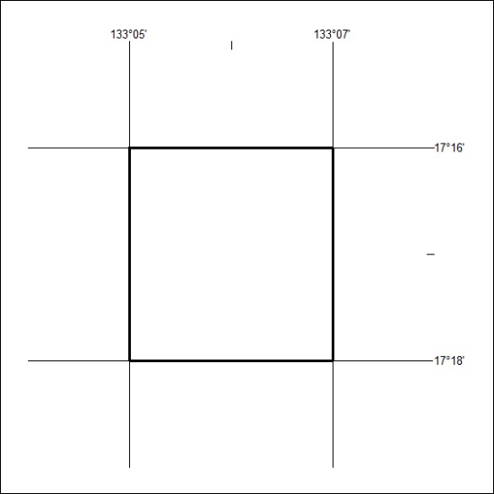
Area granted is indicated above. The titleholder is not permitted to exercise occupational rights on any land that is subject to a development title, or an application for a development title. Any land the subject of a Reserved Land gazettal under the Mineral Titles Act and all land vested in the Commonwealth of Australia is also excluded by description but not excised from the grant area.
152/21

Mineral Titles Act
NOTICE OF GRANT OF A MINERAL TITLE
Title Type and Number: | Extractive Mineral Exploration Licence 32608
Granted: | 07 May 2021, for a period of 2 Years
Area: | 4 Blocks, 13.12 km²
Locality: | NEWCASTLE WATERS
Name of Holder/s: | 100% TERRITORY SANDS PTY LTD [ACN. 632 797 972]
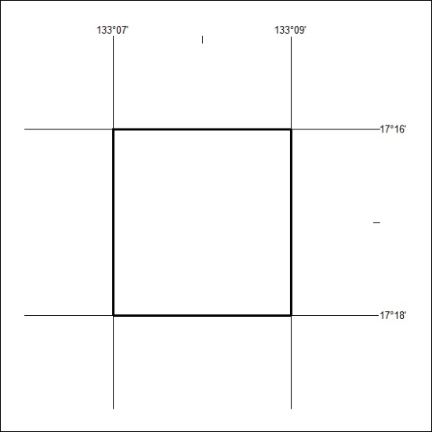
Area granted is indicated above. The titleholder is not permitted to exercise occupational rights on any land that is subject to a development title, or an application for a development title. Any land the subject of a Reserved Land gazettal under the Mineral Titles Act and all land vested in the Commonwealth of Australia is also excluded by description but not excised from the grant area.
153/21

